**The D'Arsonval galvanometer:**

**Introduction:** A D'Arsonval galvanometer is a type of instrument used for measuring small electric currents. A lot of contemporary analog meters, including voltmeters and ammeters, are based on the D'Arsonval galvanometer. The basic principle of a D'Arsonval galvanometer involves a coil of wire that is free to rotate within a magnetic field. When an electric current flows through the coil, it experiences a torque due to the interaction with the magnetic field, causing the coil to rotate. The amount of rotation is proportional to the current passing through the coil.

**Construction details:**

The D'Arsonval galvanometer consists of the following components:

• A permanent magnet or an electromagnet surrounds the coil, creating a magnetic field perpendicular to the coil

• The instrument has a lightweight coil, often rectangular or circular, made of fine wire. This coil is suspended by a torsion fiber, allowing it to rotate freely.

• A calibrated scale is placed behind the coil, allowing the user to read the current value directly from the position of the pointer on the scale.

• To prevent the pointer from oscillating excessively and to achieve stable readings, a damping mechanism is often employed. This can be in the form of air damping or fluid damping.

• A pointer is attached to the coil, and its movement is proportional to the current passing through the coil

**Principle of Operation:**

The operation of a D'Arsonval galvanometer is based on the interaction between the magnetic field and the current-carrying coil. A current-carrying conductor in a magnetic field experiences a force perpendicular to the lines of the magnetic field as well as the direction of the current. This is stated in Ampere's Law. The torque produced by this force rotates the coil.The product of the coil's current flow and the magnetic field's intensity determines the torque applied to the coil. A visible indicator of the current magnitude is provided by the connected pointer moving along the calibrated scale as the coil turns.D'Arsonval galvanometers are extremely sensitive devices that are frequently employed in situations where precise monitoring of minute currents is crucial.

**Applications:**

The d'Arsonval galvanometer is used in a wide variety of applications, including:

• Measuring small electric currents

• Detecting the presence of electric currents

• Null detectors in bridge circuits

• As the sensing element in ammeters, voltmeters, and other meters

**Advantages:**

The d'Arsonval galvanometer has several advantages, including:

• High sensitivity

•Linear response to current

•Low power consumption

•Compact size

**disadvantages:**

•The d'Arsonval galvanometer also has some disadvantages, including:

•Susceptible to vibration and shock

•Zero-center instrument, meaning it cannot indicate the direction of the current

•Limited range of measurement

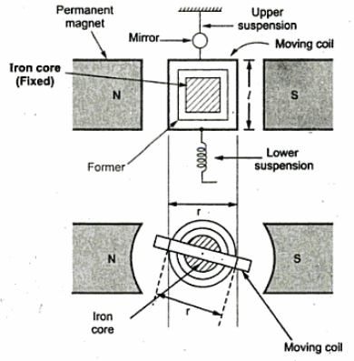

**The D'Arsonval galvanometer**

**1. Three-Wattmeter Method:**

**Introduction**: Three-Wattmeter Method is One method for determining the power in a three-phase AC. Three different wattmeters, each coupled to one of the three phases, are used in this process. Three wattmeters are primarily used to measure total power and to gather data on phase angles and power factor in a balanced or unbalanced three-phase system.

**Construction:**

•The construction involves three separate wattmeters.

•Each wattmeter has two coils - a voltage coil and a current coil.

•The coils are wound around magnetic cores to measure the magnetic fields generated by current and voltage.

• Each wattmeter has a calibrated scale and a pointer to indicate power readings.

**Principle:**

•Each wattmeter is connected to one phase of the three-phase system.

•The voltage coil is connected in parallel with the load voltage, and the current coil is connected in series with the load current.

•The torque produced by the interaction of the magnetic fields of the voltage and current coils results in a deflection of the pointer.

• The total power in the system is the sum of the readings from all three wattmeters .

**Three-Wattmeter Method:**

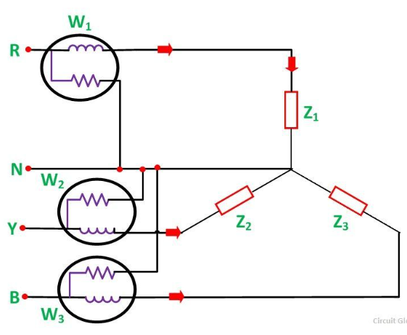

**Advantages:**

•Accurate measurement of total power and power factor.

•Suitable for both balanced and unbalanced loads

**2. Two-Wattmeter Method:**

**Introduction**: The Two-Wattmeter Method is a technique used to measure power in a three-phase AC system. This technique works with both balanced and unbalanced three-phase systems and uses two different wattmeters. The main goals are to determine the phase angles and power factor, as well as to measure the overall power.It has wye (star) connected system and delta connected system.

**Construction:**

• The construction involves two separate wattmeters.

• Similar to the three-wattmeter method, each wattmeter has voltage and current coils.

•Coils are wound around magnetic cores.

•Each wattmeter has a calibrated scale and a pointer.

**Principle:**

•The two wattmeters are connected to two phases of the three-phase system.

•Voltage coils are connected across the corresponding phase voltages, and current coils are connected in series with the corresponding line currents.

•The total power in the system is the sum of the readings from the two wattmeters.

•This method works for both balanced and unbalanced three-phase systems.

**Two-Wattmeter Method:**

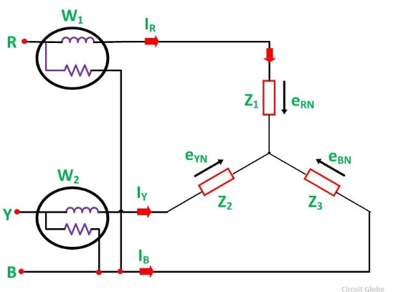

**Advantages:**

Suitable for balanced loads Simpler setup compared to the three-wattmeter method.

**3. One-Wattmeter Method:**

**Introduction**: The One-Wattmeter Method is a technique used to measure power in a three-phase AC system. In this method, a single wattmeter is employed, making it a simplified approach compared to the three-wattmeter and two-wattmeter methods. The one-wattmeter method is typically suitable for balanced three-phase systems with star-connected (Y-connected) loads.

**Construction:**

• Only a single wattmeter is used.

• It has both voltage and current coils.

• Coils are wound around magnetic cores.

• Like the other methods, it has a calibrated scale and a pointer.

**Principle:**

• The wattmeter is connected to one phase of the three-phase system.

• The voltage coil is connected across the phase voltage, and the current coil is connected in series with the line current.

• The power in the system is given by the reading of the single wattmeter.

• This method is typically used for balanced three-phase systems with star-connected (Y-connected) loads.

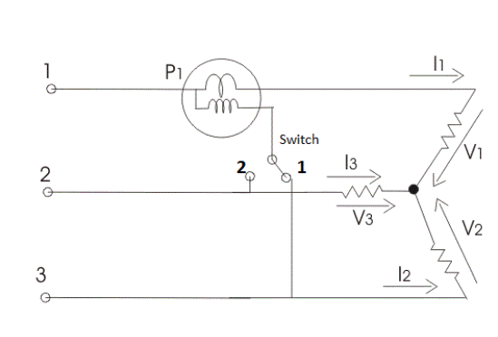

**Advantages**: Simplest setup And Suitable for single-phase loads connected to one phase of a three-phase system.

**Connection:** The wattmeter is connected between one line conductor and the common point (neutral or ground) in a wye (star) connected system. In a delta connected system, the wattmeter is connected between one line conductor and another line conductor.

**Explain how three phase power can be measured using wattmeter.**

In a three-phase power system, the total power is the sum of the power in each phase. To measure

three-phase power using a wattmeter, the three-wattmeter method is commonly employed. Here's

a step-by-step explanation:

1. Connect Wattmeters:

- Connect three separate wattmeters to each phase of the three-phase system. The wattmeters

should be appropriately rated for the voltage and current levels in the system.

2. Wattmeter Connections:

- In a wye (star) connected system, each wattmeter is connected between one of the line conductors

and the common point (neutral).

- In a delta connected system, one wattmeter is connected between two line conductors, and the

other two are connected similarly.

3. Readings and Total Power:

- Record the readings from each wattmeter. The readings represent the power in each phase.

- The total power in the three-phase system is the sum of the readings from the three wattmeters.

4. Power Factor:

- Additionally, the power factor of the system can be calculated based on the readings of the

wattmeters.

The Three-Wattmeter Method is commonly used to measure power in a three-phase AC system. In this method, three separate wattmeters are employed, each connected to one of the three phases. Here are the formulas associated with the Three-Wattmeter Method:

Power in Phase A (W_A) =Reading of Wattmeter 1

Power in Phase B (W_B) =Reading of Wattmeter 2

Power in Phase C (W_C) =Reading of Wattmeter 3

**Total Power (P)=W_A + W_B + W_C**

**Total Apparent Power (S)=√3×V_line ×I _line**

**Power Factor (PF) = P total/s**

**Megger in Power Measurement:**

A Megger, short for "megohmmeter," is typically used to measure insulation resistance in electrical systems. It is not a device designed for measuring power directly. However, it plays a crucial role in ensuring the safety and integrity of the electrical system, which indirectly contributes to power system reliability. Meggers are especially made for evaluating insulation in electrical systems and components to determine the resistance and integrity of the insulating materials,Measuring the insulation resistance in electrical circuits between conductors and ground is the usual use for a megger. This is essential for spotting any problems like rotting insulation, moisture intrusion, or other flaws that might jeopardize the functionality and safety of electrical systems, Various devices are used to measure power in terms of apparent power, reactive power, or actual power (watts). Wattmeters, power analyzers, and power meters are a few examples of devices used for measuring power. These gadgets are made to monitor the flow of electricity via a circuit and to report on various factors such as power factor and consumption.

1. A Megger applies a high voltage to the insulation of electrical components and measures the resulting current. This is used to assess the insulation resistance of cables, wires, and other components.

2. Megger tests are often performed as part of preventive maintenance to identify potential issues in the insulation before they lead to electrical faults.

3. By ensuring proper insulation, a Megger indirectly contributes to the reliability and safety of the power system. Insulation breakdown can lead to short circuits and faults that may affect the power quality and overall performance of the system.

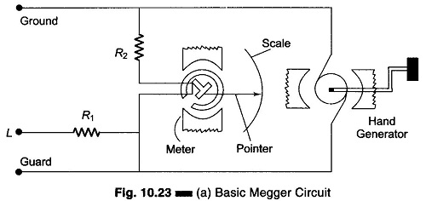

**Types of Meggers:**

• Portable meggers: These are handheld devices that are commonly used for testing electrical installations in buildings, factories, and other facilities.

• Laboratory meggers: These are more sophisticated instruments that are used for precise measurements in laboratories and manufacturing environments.

**Applications of Meggers**

Meggers are used in a variety of applications, including:

• Testing the insulation of cables, wires, and busbars.

• Assessing the condition of motors, generators, and transformers.

• Verifying the integrity of underground cables

• Troubleshooting insulation faults and potential safety hazards.

**Importance of Megger Testing**

Regular megger testing is an essential part of electrical maintenance and safety programs. It helps to identify potential insulation problems before they can cause

electrical failures or safety hazards. By conducting regular megger testing. electrical installations can be kept safe and reliable.

**The loading effect of an ohmmeter:**

The influence an ohmmeter has on the circuit or component it is measuring is referred to as its loading effect. Ohmmeters are instruments that measure resistance in electrical circuits by introducing a tiny amount of electricity into the system. The accuracy of the resistance measurement may be impacted by this current introduction, particularly in circuits with low resistance values.

The loading effect of an ohmmeter is the influence of its internal resistance on the resistance measurement. An ideal ohmmeter would have infinite internal resistance, allowing it to measure the resistance of a circuit without altering the circuit's current or voltage. However, in reality, all ohmmeters have some finite internal resistance, which can affect the accuracy of the measurement. The loading effect is most significant when measuring low-resistance components. For example, if an ohmmeter with an internal resistance of 102 is used to measure a resistor with a resistance of 102, the measured resistance will be approximately 52. This is because the ohmmeter's internal resistance acts in parallel with the resistor, effectively reducing the overall resistance of the circuit.

To minimize the loading effect, it is important to use an ohmmeter with a high internal resistance. For example, a megohmmeter is a type of ohmmeter that has a very high internal resistance, typically in the megohm range. This makes it well- suited for measuring high-resistance components, such as insulation materials. In addition to using an ohmmeter with a high internal resistance, there are other

ways to minimize the loading effect. These include:

• Using a zero-ohm adjustment knob to null out the ohmmeter's internal resistance when the test leads are shorted together.

• Using a guarded ohmmeter, which has a guard shield that surrounds the test leads and helps to isolate the measurement from external influences.

• Using a four-wire ohmmeter, which uses two additional wires to measure the current flowing through the resistor, independent of the voltage drop across it.

**AC bridges:**

AC bridges are electrical circuits used for measuring electrical quantities, such as resistance, inductance, or capacitance. These bridges are named after the inventors or contributors to their development. Here are brief descriptions of the AC bridges you mentioned:

**1.Maxwell's Bridge: -**

Purpose: Maxwell's bridge is used for the measurement of inductance.

Components: It consists of resistors, capacitors, and an unknown inductor connected in a specific configuration.

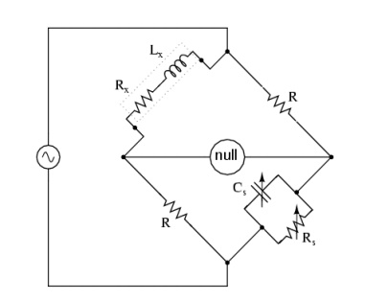

Balancing Condition: The bridge is balanced when the ratio of the inductive reactance to the resistance in one arm is equal to the ratio of the capacitive reactance to the resistance in the other arm. The unknown inductor (L_1) is placed in one arm of the bridge, and the known inductor (L_2) is placed in the other arm. The bridge is balanced by adjusting the values of the resistors ( R_1 , R_2 , R_3 , and R_4 ) until the current between the two inductors is zero. The unknown inductance can then be calculated from the values of the known inductor and the resistors.

The balance equation for Maxwell's bridge is:

L_1 / R_1 = L_2/ R_2

From this equation, the unknown inductance can be calculated as:

L_1= (R_1 / R_2) ^ * L_2

**2. Hay Bridge:**

Purpose: The Hay bridge is used for the measurement of inductance and capacitance.

Components: It typically consists of resistors, an inductor, a capacitor, and a variable resistor.

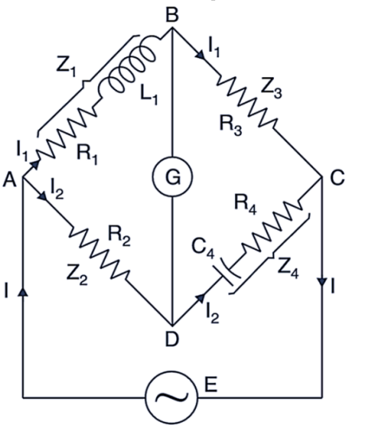

Balancing Condition: The bridge is balanced when the ratio of the inductive reactance to the resistance equals the ratio of the capacitive reactance to the resistance. It consists of four resistors and two capacitors as shown in the figure above. The unknown capacitor (C₁) is placed in one arm of the bridge, and the known capacitor (C2) is placed in the other arm. The bridge is balanced by adjusting the values of the resistors (R1, R 2, R3, and R4) until the current between the two capacitors is zero. The unknown capacitance can then be calculated from the values of the known capacitor and the resistors.

The balance equation for the Hay bridge is:

C1/R1 = C2/R2

From this equation, the unknown capacitance can be calculated as:

C 1=(R1/R2) * C2

**3. Schering Bridge:**

Purpose: The Schering bridge is primarily used for measuring the capacitance of a capacitor. Components: It includes resistors, capacitors (standard capacitor and the one under test), and a variable resistor.

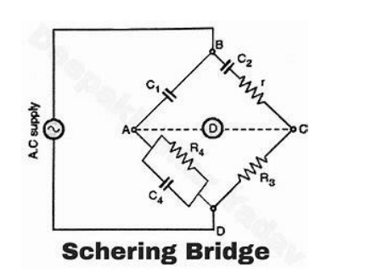

Balancing Condition: The bridge is balanced when the ratio of the capacitive reactance of the standard capacitor to the resistance is equal to the ratio of the capacitive reactance of the capacitor under test to the variable resistance.

It consists of four resistors and three capacitors as shown in the figure above. The unknown capacitor (C1) is placed in one arm of the bridge, and the known capacitors (C2 and C3) are placed in the other arms. The bridge is balanced by adjusting the values of the resistors (R1, R2, R3, and R4) until the current between the three capacitors is zero. The unknown capacitance and conductance can then be calculated from the values of the known capacitors and the resistors.

The balance equation for the Schering bridge is:

C1 / R1 + G1 = (C2+ C3) / (R2 + R3 + R4)

From this equation, the unknown inductance can be calculated as:

G1 = (C1 + C2)/(R2+R3+R4)-C1/R1

**4. Wien Bridge:**

Purpose: The Wein bridge is used for measuring the frequency of an unknown AC signal. Components: It consists of resistors, capacitors, and an operational amplifier.

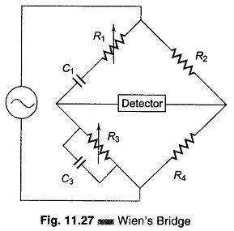

Balancing Condition: The bridge is balanced when the ratio of the capacitive reactance to the resistive impedance in one arm is equal to the ratio in the other arm. It's commonly used in audio frequency applications.

The balanced frequency is given by the formula:

f= 1/2πRC, where

R is the resistance and

C is the capacitance in the bridge network.

Applications:

The Wien Bridge is commonly used in audio frequency oscillators and signal generators.

It is also employed in frequency meters and frequency-sensitive filters.